API Rate Limiting

🚦 What is API Rate Limiting
# Source: AI Source: Provided by: [Data Path: Persons Table -> ID Column: 1, Name_En Column: Motasem Essam] -> From: [ChatGPT] on [1/19/2026]
API Rate Limiting is a technique used to control how many requests a client can send to an API within a specific time period.
👉 Think of it as a traffic control system that prevents overload and ensures fair usage.

🔑 Why Rate Limiting is Important
# Source: AI Source: Provided by: [Data Path: Persons Table -> ID Column: 1, Name_En Column: Motasem Essam] -> From: [ChatGPT] on [1/19/2026]
- Prevents abuse (spam, brute-force attacks)
- Protects server performance
- Ensures fair usage among clients
- Helps maintain availability and stability

🧱 Example
# Source: AI Source: Provided by: [Data Path: Persons Table -> ID Column: 1, Name_En Column: Motasem Essam] -> From: [ChatGPT] on [1/19/2026]
Limit Rule
100 requests per minute per user
Scenario
- Client sends 100 requests → ✅ allowed
- Sends 101st request → ❌ rejected
Response (429 Too Many Requests)
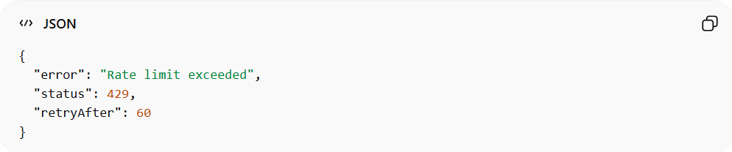
{
"error": "Rate limit exceeded",
"status": 429,
"retryAfter": 60
}
Field Breakdown
1️⃣ "error": "Rate limit exceeded"
- What it is: A human-readable error message
- Purpose: Explains why the request failed
- Meaning here:
👉 The client has sent too many requests in a short time
2️⃣ "status": 429
- What it is: The HTTP status code
- Purpose: Standard way for the server to indicate the result
- Meaning here:
👉 429 = Too Many Requests
👉 The client exceeded the allowed request limit
3️⃣ "retryAfter": 60
- What it is: Time (usually in seconds)
- Purpose: Tells the client when it can try again
- Meaning here:
👉 Wait 60 seconds before sending another request
How Client Should React
When receiving this response, a well-designed API client should:
- ⏸️ Stop sending requests temporarily
- ⏳ Wait for retryAfter (60 seconds)
- 🔁 Retry the request after the wait

🔧 Common Rate Limiting Strategies

1️⃣ Fixed Window
# Source: AI Source: Provided by: [Data Path: Persons Table -> ID Column: 1, Name_En Column: Motasem Essam] -> From: [ChatGPT] on [1/19/2026]
- Limit requests per fixed time window
- Example: 100 requests per minute
👉 Simple but can allow bursts at window edges

2️⃣ Sliding Window
# Source: AI Source: Provided by: [Data Path: Persons Table -> ID Column: 1, Name_En Column: Motasem Essam] -> From: [ChatGPT] on [1/19/2026]
- More accurate version of fixed window
- Counts requests over a rolling time period
👉 Smoother control

3️⃣ Token Bucket
# Source: AI Source: Provided by: [Data Path: Persons Table -> ID Column: 1, Name_En Column: Motasem Essam] -> From: [ChatGPT] on [1/19/2026]
- Requests consume tokens from a bucket
- Tokens refill over time
👉 Allows controlled bursts

4️⃣ Leaky Bucket
# Source: AI Source: Provided by: [Data Path: Persons Table -> ID Column: 1, Name_En Column: Motasem Essam] -> From: [ChatGPT] on [1/19/2026]
- Requests are processed at a constant rate
- Extra requests are dropped or delayed
👉 Ensures steady traffic flow

🌐 What “Window” Means in Rate Limiting
# Source: AI Source: Provided by: [Data Path: Persons Table -> ID Column: 1, Name_En Column: Motasem Essam] -> From: [ChatGPT] on [1/19/2026]
In the context of API rate limiting:
A window is a defined time period during which the server counts requests to enforce the rate limit.

🔑 Key Points
# Source: AI Source: Provided by: [Data Path: Persons Table -> ID Column: 1, Name_En Column: Motasem Essam] -> From: [ChatGPT] on [1/19/2026]
- Window = Time Interval
  - Could be seconds, minutes, hours, etc.
  - Example: 60 seconds, 1 minute, 1 hour
- Server tracks requests in that window
  - Only a certain number of requests are allowed inside the window
- Purpose
  - Prevent clients from sending too many requests in a short period
  - Protect server resources and maintain fairness

🧱 Examples

Fixed Window
# Source: AI Source: Provided by: [Data Path: Persons Table -> ID Column: 1, Name_En Column: Motasem Essam] -> From: [ChatGPT] on [1/19/2026]
- Window = 60 seconds
- Limit = 5 requests
Time | Requests Counted in Window
00:00–00:59 | Count all requests in this minute
01:00–01:59 | Count resets, new minute starts
Each “minute” is a fixed window. Requests only count within that minute.

Sliding Window
# Source: AI Source: Provided by: [Data Path: Persons Table -> ID Column: 1, Name_En Column: Motasem Essam] -> From: [ChatGPT] on [1/19/2026]
- Window = last 60 seconds
- Limit = 5 requests
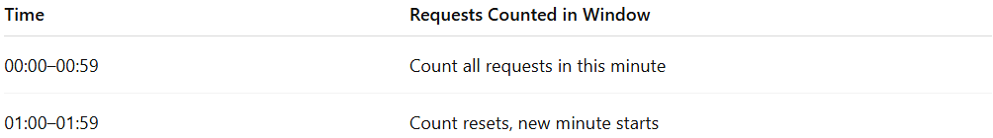
Time | Requests Counted in Window
00:50 | Count requests from 00:50 → 00:50-60 = 23:50 previous hour
01:01 | Count requests from 01:01 → 01:01-60 = 00:01
Here, the “window” slides continuously as time moves — it’s not fixed to exact minute boundaries.

🔑 Analogy
# Source: AI Source: Provided by: [Data Path: Persons Table -> ID Column: 1, Name_En Column: Motasem Essam] -> From: [ChatGPT] on [1/19/2026]
- Fixed Window: Think of a parking lot with per-hour tickets. At 2:00 pm the counter resets.
- Sliding Window: Think of a rolling 60-minute parking ticket that starts whenever you arrive, not at the start of the hour.

Summary:
# Source: AI Source: Provided by: [Data Path: Persons Table -> ID Column: 1, Name_En Column: Motasem Essam] -> From: [ChatGPT] on [1/19/2026]
Window = the time frame in which requests are counted and limited

📬 Rate Limiting Headers
# Source: AI Source: Provided by: [Data Path: Persons Table -> ID Column: 1, Name_En Column: Motasem Essam] -> From: [ChatGPT] on [1/19/2026]
Servers often include headers to inform clients:
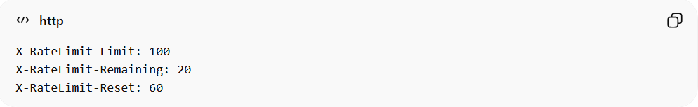
X-RateLimit-Limit: 100
X-RateLimit-Remaining: 20
X-RateLimit-Reset: 60
- Limit → max requests allowed
- Remaining → requests left
- Reset → time until reset

❌ Common Mistakes
# Source: AI Source: Provided by: [Data Path: Persons Table -> ID Column: 1, Name_En Column: Motasem Essam] -> From: [ChatGPT] on [1/19/2026]
- No rate limiting at all ❌
- Applying same limit to all users (no flexibility) ❌
- Not returning clear error messages ❌

✅ Best Practices
# Source: AI Source: Provided by: [Data Path: Persons Table -> ID Column: 1, Name_En Column: Motasem Essam] -> From: [ChatGPT] on [1/19/2026]
- Use different limits for different users (e.g., free vs premium)
- Return 429 status code when limit exceeded
- Provide retry information
- Log and monitor usage

💡 Summary
# Source: AI Source: Provided by: [Data Path: Persons Table -> ID Column: 1, Name_En Column: Motasem Essam] -> From: [ChatGPT] on [1/19/2026]
API Rate Limiting protects your API by controlling traffic, ensuring fairness, and preventing system overload.

